TO: The Honorable Mark M. Nakashima, Chair, The Honorable Scot Z. Matayoshi, Vice Chair, and Honorable Members of the Committee on Human Services

FROM: Marci Hamilton, CEO & Legal Director, CHILD USA; Robert A. Fox Professor of Practice, University of Pennsylvania and Kathryn Robb, Executive Director, CHILD USAdvocacy

RE: HB 568, elimination of criminal SOL for child sex trafficking

DATE: February 22, 2021

Dear Chairwoman, Vice Chairman, and Members of the Committee on Human Services,

Thank you for allowing us, Professor Marci Hamilton of CHILD USA and Kathryn Robb of CHILD USAdvocacy, to submit testimony regarding HB 568, which will increase access to justice for victims of childhood sex trafficking and enhance protection for children in Hawaii. If passed, this legislation will make Hawaii a leader in the fight to protect children’s rights.

By way of introduction, Marci Hamilton is the Founder, CEO, and Legal Director of CHILD USA, an interdisciplinary think tank dedicated to the prevention of child abuse and neglect at the University of Pennsylvania, where she is a Professor in the Fels Institute of Government. She authored Justice Denied: What America Must Do to Protect Its Children (Cambridge University Press 2008, 2012), which makes the case for statute of limitations (SOL) reform in the child sex abuse arena, and is the leading expert on the history and constitutionality of SOL reform.

CHILD USA is the leading nonprofit think tank dedicated to the prevention of child abuse and neglect. It is also the leader in the field of statute of limitations, or “SOL” reform, and the only organization to track child sex abuse SOLs in every state, D.C., and the federal government.

Kathryn Robb is the Executive Director of CHILD USAdvocacy, a 501(c)(4) advocacy organization dedicated to protecting children’s civil liberties and keeping children safe from abuse and neglect. CHILD USAdvocacy draws on the combined expertise of the nation’s leading experts and child advocates, specifically its sister organization, CHILD USA. Kathryn is also a survivor of child sexual abuse.

We commend you and the Committee for taking up HB 568 (and its companion in the Senate, SB 831). HB 568 would eliminate the criminal SOL for child sex trafficking crimes, as well as clarify the definition of sex trafficking to include non-monetary compensation. HB 568 would remove references to childhood “prostitution” and use more correct language like “commercial sexual exploitation.” If passed, this legislation will bring Hawaii closer to being a leader in the fight to protect children's rights.

- HB 568 Will Correctly Identify Children as Victims

According to federal law, any child engaged in commercial sex is a victim of a severe form of sex trafficking. The federal law correctly acknowledges that children are incapable of consenting to sex. Moreover, anyone over the age of 18 engaged in commercial sex who has experienced any form of physical or sexual force, coercive grooming, financial coercion, or manipulative fraud at any time is also considered a victim.

HB 568 removes the language of “prostitution” from its laws, and correctly identifies children as victims, bringing its interpretation into line with federal law. It also underscores this change by removing consent as a possible defense for child sex trafficking and clarifies the definition of trafficking to include both coercion and solicitation. These changes encourage an attitude shift in victims, law enforcement, members of the judiciary, and the public to recognize victims as victims, and to remove misplaced stigma that may keep victims from coming forward.
- The Science of Delayed Disclosure Supports SOL Reform for Child Sex Trafficking

There is a worldwide epidemic of child sex trafficking, with millions of people being trafficked for sex, 94% of which are women and girls. In 2019, Polaris Project worked on trafficking situations involving 22,326 individual survivors in the United States through the National Trafficking Hotline. According to the National Center for Missing and Exploited Children, 1 out of 6 children reported missing is “likely [a victim] of child sex trafficking” based on case information. In a recent joint study by Arizona State University and the Hawai’i State Commission on the Status of Women conducted from April-June 2019, 1 out of 5 victims of sex trafficking in Hawaii were trafficked as children.

The trauma stemming from child sexual abuse is complex and individualized, and it impacts victims throughout their lifetimes. There is an overwhelming body of science exposing the ways in which the trauma of sexual abuse during childhood impacts memory formation and the repression of memories. It is now settled that PTSD, memory deficits, and complete disassociation are common coping mechanisms for child victims. As a result, it can take years for a victim to acknowledge their abuse.

Trauma is only one of the barriers preventing children from disclosing abuse. “Among other barriers, children often lack the knowledge needed to recognize sexual abuse, lack the ability to articulate that they have been abused, don’t have an adult they can disclose their abuse to, don’t have opportunities to disclose abuse, and aren’t believed when they try to disclose.” Studies suggest that many victims, as much as 33%, never disclose their abuse. The disclosure of child sexual abuse is a process and not a discrete event in which a victim comes to terms with their abuse. Often this happens in the context of therapy; sometimes it is triggered many years after the abuse by an event the victim associates with the abuse; other times it happens gradually and over time as a victim recovers their memory.

In fact, the average age of disclosure of child sexual abuse, including child sex trafficking, in a study of 1,000 victims was 52 years-old. Yet, until recently, many states blocked criminal charges and civil lawsuits well before age 52. By the time most victims were ready to come forward, the courthouse doors were locked, shutting victims out of justice.
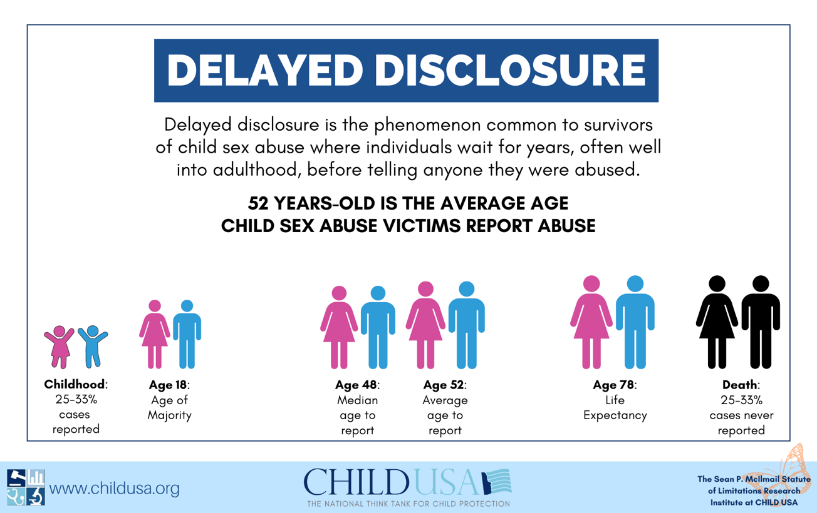

It is a medical fact that victims of child sex trafficking often need decades to come forward. They are traumatized from the abuse, incapable of processing what happened to them, and often dependent on the adults who perpetrated or caused the abuse. Short SOLs for child sex trafficking play into the hands of the perpetrators and the institutions enable them; they disable victims’ voices and empowerment. Because of its lifelong effect on health and well-being that can erect high barriers to disclosure and the fact that many perpetrators pursue and assault children even in their elder years, childhood sexual abuse needs to be added to the list of laws that should not be subject to an SOL, like kidnapping, fraud and embezzlement, war crimes, treason, and murder in the United States. HB 568 seeks to do just that.

- HB 568 Will Serve the Public Good by Increasing Victims’ Access to Justice and Preventing Future Abuse

Statutes of limitations or SOLs are judicial housekeeping rules: they set the deadline for pressing criminal charges or filing a civil lawsuit. An SOL is an arbitrary and technical legal rule that has prevented victims from naming their perpetrators publicly for fear of retaliation and from obtaining justice.

Current Hawaii law provides that a prosecution for child sex trafficking must be commenced within 6 years of the abuse, or by a victim’s 24th birthday. HB 568 would eliminate the criminal SOL, allowing more victims to come forward when they are ready.

Historically, a wall of ignorance and secrecy has been constructed around child sex abuse, which has been reinforced by short SOLs that kept victims out of the legal system. Perpetrators and institutions have benefitted from short SOLs and until recently, most states have shut down most cases. That is a major reason we knew so little about the epidemic of child sex abuse and child sex trafficking. Yet, it is in society’s interest to have sex abuse survivors identify hidden child predators to the public—whenever the survivor is ready.

As well as providing already-existing victims of abuse a path to justice, SOL reform protects society at large. By allowing prosecutors and victims all the time they need to prosecute a child sex trafficking case, hidden predators are brought into the light and are prevented from further abusing more children. Preventing further abuse only serves to help –society—by reducing the costs of healthcare for victims, allowing more healthy people into the workforce, and increasing the ability of children to grow into healthy adults. SOL reform also educates the public about the danger of child sexual abuse.

- Hawaii Should Join the National Trend Toward Meaningful SOL Reform for Child Sex Abuse by Eliminating its Criminal SOL for Child Sex Trafficking

There is a national and global movement for SOL reform. The trend is toward elimination of civil and criminal SOLs and the revival of expired civil claims. For an analysis of the SOL reform movement from 2002 through 2020, see CHILD USA’s 2020 SOL Report. 2019 was a banner year for helping child sex abuse survivors access justice by changing the statutes of limitations. With the public more awake than they’ve ever been to the injustice survivors faced by being shut out of courts, there was a surge of SOL reform, with 23 states and Washington D.C changing their SOLs for the better in 2019. The powerful SOL reform wave rode its way into 2020, with 30 states introducing legislation, but the outbreak of Covid-19 slowed its momentum. Despite significant disruptions by Covid-19 in 2020, 8 states passed new and improved SOL laws for child sex abuse. By February of 2021, 27 states have already introduced SOL reform bills.

This proposed elimination of the criminal SOL among the other changes suggested in HB 568 is in line with the recent trend to eliminate the criminal SOL and to give victims into their 50’s time to come forward in accordance with the delayed disclosure of abuse science. Hawaii has already eliminated the criminal SOL for first and second-degree sexual assault and continuous sexual assault of a minor under age 14, so HB 568 corrects the omission of child sex trafficking from that list. It also better aligns Hawaii’s definitions of child sex trafficking to those of the federal government, to highlight the reality that children involved in sex trafficking are victims.

Once again, we commend you for supporting this legislation, which is desperately needed to help survivors of childhood sexual abuse, and for taking up the cause of child sex abuse victims. Hawaii’s children deserve SOL reform to protect them today and into the future. Extending the time for survivors to file suit and opening a window for expired claims is a positive step for Hawaii’s children and families. Please do not hesitate to contact us if you have questions regarding SOL reform or if we can be of assistance in any way on other child protection issues.

Sincerely,
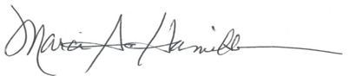
Marci A. Hamilton, Esq.
Founder, CEO & Legal Director
CHILD USA
3508 Market Street, Suite 202
Philadelphia, PA 19104
(215) 539-1906


Kathryn Robb, Esq.
Executive Director
CHILD USAdvocacy
3508 Market St., Suite 201
Philadelphia, PA 19104

22 U.S.C. § 7102(11)(a).
Global Report on Trafficking in Persons, UNODC, 33 (2018), available at https://www.unodc.org/documents/data-and-analysis/glotip/2018/GLOTiP_2018_BOOK_web_small.pdf.
Myths, Facts, and Statistics, Polaris Project (last visited February 11, 2021), available at https://polarisproject.org/myths-facts-and-statistics/.
K. Tate Chambers, Ed., Human Trafficking, 65 U.S. Attorney’s Bulletin, 33 (Nov. 2017), available at https://www.justice.gov/usao/page/file/1008856/download.
See Dominique Roe-Sepowitz & Khara Jabola-Carolus, Sex Trafficking in Hawai’i: Part III, ASU (Jan. 2020), available at https://humanservices.hawaii.gov/wp-content/uploads/2020/02/ST-in-Hawai%E2%80%98i-Executive-Summary-January-2020-FINAL-2.pdf.
van der Kolk, B. The Body Keeps the Score: Memory & the Evolving Psychobiology of Posttraumatic Stress, Harvard Rev. of Psychiatry (1994) 1(5), 253-65; Jim Hopper, Why Can’t Christine Blasey Ford Remember How She Got Home?, Scientific Amer. (Oct. 5, 2018), available at https://blogs.scientificamerican.com/observations/why-cant-christine-blasey-ford-remember-how-she-got-home/;see also Hoskell, L. & Randall, M., The Impact of Trauma on Adult Sexual Assault Victims, Justice Canada 30 (2019), available at https://www.justice.gc.ca/eng/rp-pr/jr/trauma/trauma_eng.pdf (hereinafter “Hoskell”).
Jacobs-Kayam.A. and Lev-Weisel, R., In Limbo: Time Perspective and Memory Deficit Among Female Survivors of Sexual Abuse, Frontiers in Psychol. (April 24, 2019) available at https://www.frontiersin.org/articles/10.3389/fpsyg.2019.00912/full.
CHILD USA, Delayed Disclosure: A Factsheet Based on Cutting-Edge Research on Child Sex Abuse, CHILDUSA.ORG, 3 (Mar. 2020) available at https://childusa.org/wpcontent/uploads/2020/04/Delayed-Disclosure-Factsheet-2020.pdf. (citing N. Spröber et. al., Child sexual abuse in religiously affiliated and secular institutions, 14 BMC Pub. Health 282, 282 (2014).
Id.
Hoskell, at 24.
CHILD USA, Delayed Disclosure: A Factsheet Based on Cutting-Edge Research on Child Sex Abuse, CHILDUSA.ORG, 3 (Mar. 2020) available at https://childusa.org/wpcontent/uploads/2020/04/Delayed-Disclosure-Factsheet-2020.pdf.
Haw. Rev. Stat. Ann. § 701-108.
2020 SOL Report, childusa.org (last visited Feb. 10, 2021), available at www.childusa.org/sol-report-2020.
For more information on SOL reform in 2019, visit 2019 Summary of Child Sexual Abuse Statutes of Limitations (SOLs): Introduced, Signed into Law and State Laws by Category, childusa.org (last visited Jan. 22, 2021), available at www.childusa.org/2019sol.
See 2020 SOL Summary, childusa.org (last visited Jan. 30, 2021), available at www.childusa.org/2020sol.
See id.

