

TO: Distinguished Members of the Senate Judiciary Subcommittee

FROM: Marci Hamilton, Esq., Founder & CEO, CHILD USA; Professor, University of Pennsylvania, and Kathryn Robb, Esq., Executive Director, CHILD USAdvocacy

RE: Testimony in Support of S0591 re: Child Marriage

DATE: April 28, 2021
_____________________________________________________________________________

Dear distinguished members of the Senate Judiciary Subcommittee,

Thank you for allowing us, Professor Marci Hamilton of CHILD USA and Kathryn Robb of CHILD USAdvocacy, to submit testimony regarding S0591, which will eliminate the dangerous “parental consent” loophole to the minimum age requirement and keep the marriage age at 18. This legislation, if passed, would place South Carolina in the top five states for protecting children from the trauma of underage marriage.

By way of introduction, Marci Hamilton is the Founder and CEO of CHILD USA, an interdisciplinary think tank dedicated to the prevention of child abuse and neglect at the University of Pennsylvania, where she is a Professor in the Fels Institute of Government. She authored Justice Denied: What America Must Do to Protect Its Children (Cambridge University Press 2008, 2012), which makes the case for statute of limitations (SOL) reform in the child sex abuse arena and is the leading expert on the history and constitutionality of SOL reform.

CHILD USA is the leading nonprofit think tank dedicated to the prevention of child abuse and neglect. It is also the leader in the field of SOL reform, as well as other cutting-edge issues related to child protection, like child marriage.

Kathryn Robb is the Executive Director of CHILD USAdvocacy, a 501(c)(4) advocacy organization dedicated to protecting children’s civil liberties and keeping children safe from abuse and neglect. CHILD USAdvocacy draws on the combined expertise of the nation’s leading experts and child advocates, specifically its sister organization, CHILD USA.

Child marriage is a global problem. It is defined as marriage of a child under age 18 and is a far more common practice than many believe. Worldwide estimates suggest that at least 650,000,000 million girls and women alive today were married as children. This equates to roughly 15 million girls being married each year—before they are 18.

Child marriage is a gendered practice, negatively affecting women far more than men. It is often used to aid in the cover up of statutory rape or assault. Remarkably, marriage is a defense to statutory rape with 12 to 15-year-olds at the federal level, as well as within a majority of U.S. states. In order to protect children and secure their futures, the practice of child marriage must be outlawed.

There is a common misconception that child marriage is not a problem in developed countries like the United States, but at least 200,000 children were married here between 2000-15, 87% of whom were female. Nearly every state permits child marriage in some form. More than half of the states permit child marriage with either parental or judicial consent. Other states have religious or pregnancy exceptions, permitting the practice to continue. In fact, only four states have banned child marriage outright: Delaware (May 2018), the first state to ban the practice, New Jersey (June 2018), Pennsylvania (May 2020), and Minnesota (May 2020); however, bills seeking to outlaw child marriage are currently pending in several other states..

Women and girls who are married before reaching adulthood are far more likely to experience physical or sexual violence than those who marry as adults, are far more likely to believe that domestic violence is justified, and are at a higher risk for sexually transmitted diseases and infections, more general health issues, and nutritional deficiencies. The negative consequences extend beyond simply the children forced into marriage—the “infant mortality rate is 60% higher” for mothers under 18. When young girls are married, they tend to have children earlier, leading to increase of complications during pregnancy and childbirth for the mother, as well as increased risks for the child.

Child marriage leads to unhealthy isolation for children as well as both educational disadvantage and higher rates of poverty. While child marriage is most common in conservative religious communities and poor rural areas, men and women married as children remain a hidden population. As such, there is insufficient data available to show the true breadth and scope of the problem. More research must be done to better protect children.
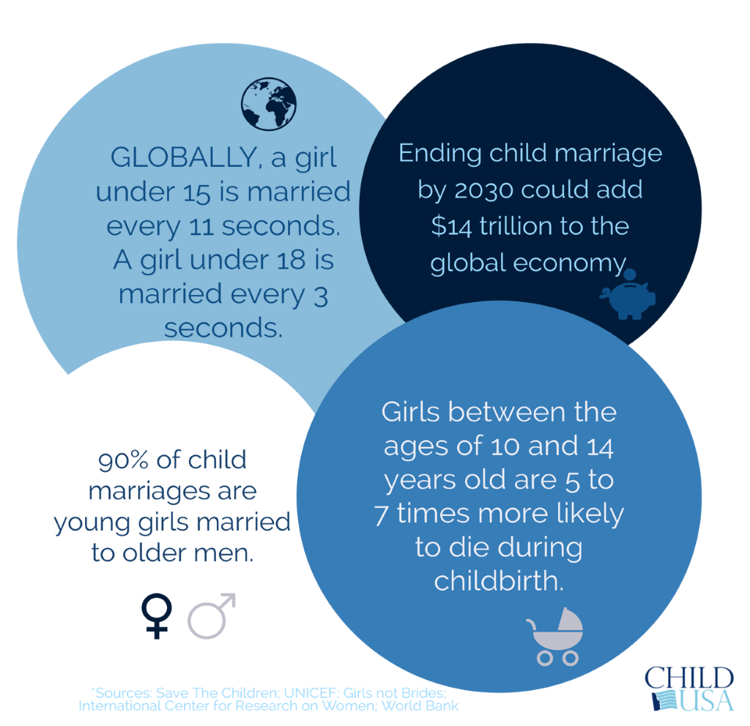

Early marriage increases an adolescent’s likelihood of descending into poverty when compared to an individual married in adulthood, as well as the likelihood of separation or divorce. Recognizing these dangers, which are just as real in the United States as they are internationally, there is a growing national and international trend to limit or completely ban the practice of child marriage.

For those who believe that child marriage is not a problem in the United States, countless and horrifying tales regarding the practice prove otherwise. In Utah, two men in their mid-thirties married one another’s seven- and eight-year-old daughters. The marriages were only discovered when an ex-wife of one of the men contacted law enforcement with allegations of kidnapping. The young girls were discovered freezing and stuffed into water barrels, where they had been placed to avoid law enforcement. According to Frontline data, in Alabama, a 14-year-old girl was married to a 74-year-old man, a sixty-year age gap. Other children have been brought across state lines to help facilitate child marriage. A well-known example is that of an Idahoan father who brought his 14-year-old daughter to Missouri to be married to a man 10 years her senior; the man was later convicted of raping his young wife.

The UN Convention on the Rights of the Child (“CRC”) is an international human rights treaty covering child-specific rights. Specifically, the CRC requires that adults act in the best interests of children when making decisions that may affect children. The CRC recommends setting a mandatory minimum age for marriage at 18, applicable to both genders.

Notably, the United States is the only country that has not ratified the UN Convention on the Rights of the Child. Because the United States is not a signatory to the CRC, it is up to individual states to ensure the safety of their children, following the example set by Delaware, New Jersey, Pennsylvania, and Minnesota and banning child marriage. We commend you for recognizing this and taking up this charge on behalf of South Carolina’s children.

Please do not hesitate to contact us if we can be of assistance on this or any other child protection issues.

Sincerely,


Marci A. Hamilton, Esq. Kathryn Robb, Esq.
Professor, Fels Institute of Government Executive Director
University of Pennsylvania CHILD USAdvocacy
3508 Market Street, Suit 201
Founder & CEO Philadelphia, PA 19104
CHILD USA krobb@childusadvocacy.org
3508 Market Street, Suite 202 Tel: (781) 856-7207
Philadelphia, PA 19104
mhamilton@childusa.org
Tel: (215) 539-1906

Sarah Ferguson, What You Need to Know About Child Marriage in the U.S., UNICEF (Oct. 29, 2018), available at https://www.unicefusa.org/stories/what-you-need-know-about-child-marriage-us/35059 (2018); see also The World’s Youth, Population Reference Bureau (2006), available at https://assets.prb.org/pdf06/WorldsYouth2006DataSheet.pdf.
5 Things You Should Know about Child Marriage and The Law In the United States, Equality Now: A just world for women and girls (May 24, 2019), https://www.equalitynow.org/5_things_you_should_know_about_child_marriage_the_us (last visited Mar. 21, 2021).
Supra n.1 (according to its study of 41 states; the remaining 9 states did not provide data; the number is likely higher).
Marci A. Hamilton, 2020 Report on Child Marriage in the United States: A National Overview of Child MarriageData and Law, childusa.org (May 8, 2020) available at https://childusa.org/wp-content/uploads/2020/04/2020-Report-on-Child-Marriage-in-the-US.pdf.
Negar Omidakhsh & Jody Heymann, Improved Child Marriage laws and its Association with Changing Attitudes and Experiences of Intimate Partner Violence: A Comparative Multi-National Study, 10 J. Glob. Health (2020), available at https://www.ncbi.nlm.nih.gov/pmc/articles/PMC7101085/.
Nour NM, Child marriage: a silent health and human rights issue, 2(1) Rev. Obstet. Gynecol. 51–56 (2009).
Id.
Jensen & Thornton, Early Female Marriage in the Developing World, 11 (2) Gender & Dev 9–19 (2003); Ending Child Marriage: Progress and Prospects, UNICEF Div. of Pol’y & Res. (Nov. 21, 2014), available at http://www.unicef.org/media/files/Child_Marriage_Report_7_17_LR.pdf.
Aditi Wahi et al, The Lived Experience of Child Marriage in the United States, Soc. Work In Pub. Health (2019).
Hamilton supra note 3.
Bryn Lovitt, Third Man Accused of Child Marriage in Utah Sex Cult, Rolling Stone, (June 11, 2018) available at https://www.rollingstone.com/culture/culture-news/third-man-accused-of-child-marriage-in-utah-sex-cult-630073/.
Anjali Tsui, et al., Child Marriage in America by the Numbers, Frontline.org (July 6, 2017), available at http://apps.frontline.org/child-marriage-by-the-numbers/.
APNews.com , Father who had daughter marry her rapist sentenced to jail, (May 31, 2016) available at https://apnews.com/article/4fe38d09aaad4a8c98f73b3d4af9a5f2
United Nations Convention on the Rights of the Child, Nov. 20, 1989, available at http://www.ohchr.org/en/professionalinterest/pages/crc.aspx

