TO: The Honorable Karl Rhoads, Chair, The Honorable Jarrett Keohokalole, Vice Chair, and Honorable Members of the Senate Committee on Judiciary

FROM: Marci Hamilton, CEO & Legal Director, CHILD USA; Robert A. Fox Professor of Practice, University of Pennsylvania and Kathryn Robb, Executive Director, CHILD USAdvocacy

RE: SB 48, regarding child sex trafficking

DATE: February 22, 2021

Dear Chairman, Vice Chairman, and Members of the Senate Committee on Judiciary,

Thank you for allowing us, Professor Marci Hamilton of CHILD USA and Kathryn Robb of CHILD USAdvocacy, to submit testimony regarding SB 48, which will increase access to justice for victims of childhood sex trafficking and enhance protection for children in Hawaii. If passed, this legislation will make Hawaii a leader in the fight to protect children’s rights.

By way of introduction, Marci Hamilton is the Founder, CEO, and Legal Director of CHILD USA, an interdisciplinary think tank dedicated to the prevention of child abuse and neglect at the University of Pennsylvania, where she is a Professor in the Fels Institute of Government. She authored Justice Denied: What America Must Do to Protect Its Children (Cambridge University Press 2008, 2012), which makes the case for statute of limitations (SOL) reform in the child sex abuse arena, and is the leading expert on the history and constitutionality of SOL reform.

CHILD USA is the leading nonprofit think tank dedicated to the prevention of child abuse and neglect. It is also the leader in the field of statute of limitations, or “SOL” reform, and the only organization to track child sex abuse SOLs in every state, D.C., and the federal government.

Kathryn Robb is the Executive Director of CHILD USAdvocacy, a 501(c)(4) advocacy organization dedicated to protecting children’s civil liberties and keeping children safe from abuse and neglect. CHILD USAdvocacy draws on the combined expertise of the nation’s leading experts and child advocates, specifically its sister organization, CHILD USA. Kathryn is also a survivor of child sexual abuse.

We commend you and the Committee for taking up SB 48.

SB 48 would include solicitation as a child sex trafficking crime, as well as clarify the definition of sex trafficking to include non-monetary compensation, remove consent as a defense to child sex trafficking, and expand the definition to include an inchoate offense. A prior version of this legislation included a necessary elimination of the statute of limitations to prosecute these crimes, and we strongly urge you to reinstate this language. If passed, this legislation will bring Hawaii closer to being a leader in the fight to protect children's rights.

- SB 48 Will Correctly Identify Children as Victims, and Accurately Capture Perpetrators

There is a worldwide epidemic of child sex trafficking, with millions of people being trafficked for sex, 94% of which are women and girls. In 2019, Polaris Project worked on trafficking situations involving 22,326 individual survivors in the United States through the National Trafficking Hotline. According to the National Center for Missing and Exploited Children, 1 out of 6 children reported missing is “likely [a victim] of child sex trafficking” based on case information. In a recent joint study by Arizona State University and the Hawaii State Commission on the Status of Women conducted from April-June 2019, 1 out of 5 victims of sex trafficking in Hawaii were trafficked as children.

According to federal law, any child engaged in commercial sex is a victim of a severe form of sex trafficking. The federal law correctly acknowledges that children are incapable of consenting to sex. Moreover, anyone over the age of 18 engaged in commercial sex who has experienced any form of physical or sexual force, coercive grooming, financial coercion, or manipulative fraud at any time is also considered a victim.

SB 48 correctly identifies children as victims, bringing attempted solicitation of a minor for prostitution into the definition of sex trafficking, and into line with the federal law. It also underscores this change by removing consent as a possible defense for child sex trafficking. These changes encourage an attitude shift in victims, law enforcement, members of the judiciary, and the public to recognize victims as victims, and to remove misplaced stigma that may keep victims from coming forward.
SB 48 seeks to broaden the definition of a sex trafficking, which would bring Hawaii law in line with federal law which defines sex trafficking as “the recruitment, harboring, transportation, provision, obtaining, patronizing, or soliciting of a person for the purpose of a commercial sex act.”

- A prior version of SB 48 Eliminated the Statute of Limitations for Child Sex Trafficking Prosecution, and it is Important to Reinstate this Language

Current Hawaii law provides that a prosecution for child sex trafficking must be commenced within 6 years of the abuse, or by a victim’s 24th birthday. A prior version of SB 48 sought to eliminate the criminal SOL, allowing more victims to come forward when they are ready, but that language has been removed from the current version. We urge you to reinstate this language, as the trauma stemming from child sexual abuse is complex and individualized, and it impacts victims throughout their lifetimes. Hawaii has already eliminated the criminal SOL for first and second-degree sexual assault and continuous sexual assault of a minor under age 14, so reinstating the criminal SOL elimination in SB 48 would correct the omission of child sex trafficking from that list. It would also better align Hawaii’s definitions of child sex trafficking to those of the federal government, to highlight the reality that children involved in sex trafficking are victims.

Statutes of limitations or SOLs are judicial housekeeping rules: they set the deadline for pressing criminal charges or filing a civil lawsuit. An SOL is an arbitrary and technical legal rule that has prevented victims from naming their perpetrators publicly for fear of retaliation and from obtaining justice. In fact, the average age of disclosure of child sexual abuse, including child sex trafficking, in a study of 1,000 victims was 52 years-old. Yet, until recently, many states blocked criminal charges and civil lawsuits well before age 52. By the time most victims were ready to come forward, the courthouse doors were locked, shutting victims out of justice.
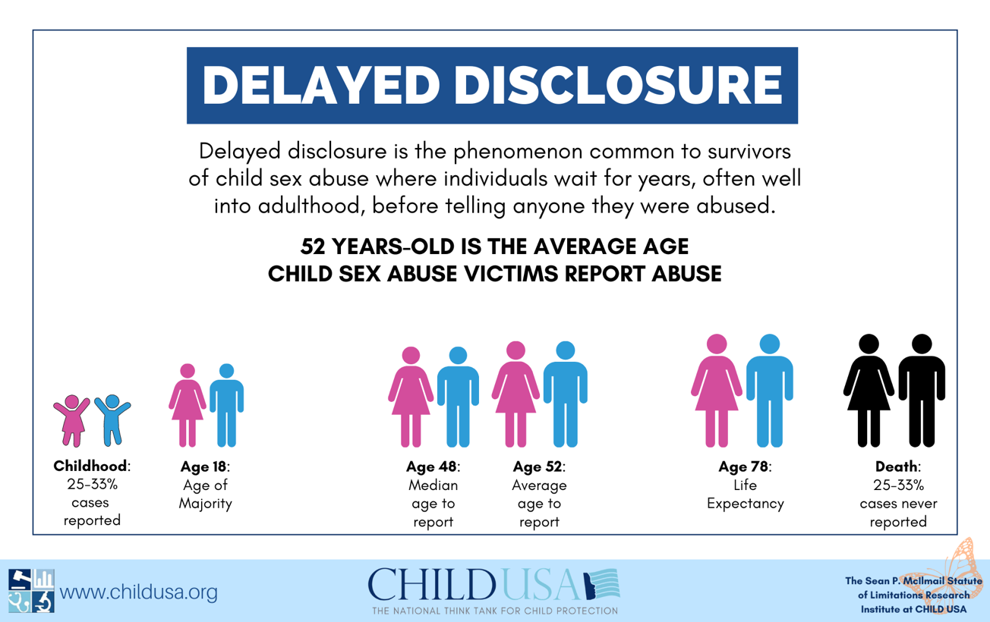

- Hawaii Should Join the National Trend Toward Meaningful SOL Reform for Child Sex Abuse by Eliminating its Criminal SOL for Child Sex Trafficking

There is a national and global movement for SOL reform. The trend is toward elimination of civil and criminal SOLs and the revival of expired civil claims. For an analysis of the SOL reform movement from 2002 through 2020, see CHILD USA’s 2020 SOL Report. 2019 was a banner year for helping child sex abuse survivors access justice by changing the statutes of limitations. With the public more awake than they’ve ever been to the injustice survivors faced by being shut out of courts, there was a surge of SOL reform, with 23 states and Washington D.C changing their SOLs for the better in 2019. The powerful SOL reform wave rode its way into 2020, with 30 states introducing legislation, but the outbreak of Covid-19 slowed its momentum. Despite significant disruptions by Covid-19 in 2020, 8 states passed new and improved SOL laws for child sex abuse. By February of 2021, 27 states have already introduced SOL reform bills.

Once again, we commend you for supporting this legislation, which is desperately needed to help survivors of childhood sexual abuse, and for taking up the cause of child sex abuse victims. An expanded definition of child sex trafficking, and the removal of consent as a defense to child sex trafficking, are important steps toward protecting Hawaii’s children. We strongly urge you to reinstate the prior language extending the criminal SOL for child sex trafficking offenses. Hawaii’s children deserve SOL reform to protect them today and into the future. Extending the time for survivors to file suit and opening a window for expired claims is a positive step for Hawaii’s children and families. Please do not hesitate to contact us if you have questions regarding SOL reform or if we can be of assistance in any way on other child protection issues.

Sincerely,
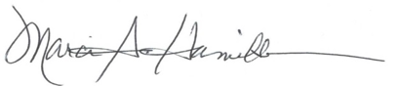
Marci A. Hamilton, Esq.
Founder, CEO & Legal Director
CHILD USA
3508 Market Street, Suite 202
Philadelphia, PA 19104
(215) 539-1906

Kathryn Robb, Esq.
Executive Director
CHILD USAdvocacy
3508 Market St., Suite 201
Philadelphia, PA 19104

Global Report on Trafficking in Persons, UNODC, 33 (2018), available at https://www.unodc.org/documents/data-and-analysis/glotip/2018/GLOTiP_2018_BOOK_web_small.pdf.
Myths, Facts, and Statistics, Polaris Project (last visited February 11, 2021), available at https://polarisproject.org/myths-facts-and-statistics/.
K. Tate Chambers, Ed., Human Trafficking, 65 U.S. Attorney’s Bulletin, 33 (Nov. 2017), available at https://www.justice.gov/usao/page/file/1008856/download.
22 U.S.C. § 7102(11)(a).
22 U.S.C. § 7102(12).
Haw. Rev. Stat. Ann. § 701-108.
CHILD USA, Delayed Disclosure: A Factsheet Based on Cutting-Edge Research on Child Sex Abuse, CHILDUSA.ORG, 3 (Mar. 2020) available at https://childusa.org/wpcontent/uploads/2020/04/Delayed-Disclosure-Factsheet-2020.pdf.
2020 SOL Report, childusa.org (last visited Feb. 10, 2021), available at www.childusa.org/sol-report-2020.
For more information on SOL reform in 2019, visit 2019 Summary of Child Sexual Abuse Statutes of Limitations (SOLs): Introduced, Signed into Law and State Laws by Category, childusa.org (last visited Jan. 22, 2021), available at www.childusa.org/2019sol.
See 2020 SOL Summary, childusa.org (last visited Jan. 30, 2021), available at www.childusa.org/2020sol.
See id.

